**CE 4951 COURSE PROJECT**

**MESSAGE-EXCHANGING NODES ON CSMA/CD BUS USING MANCHESTER LINE CODING WITH BUS THAT IDLES HIGH**

**TEST PROCEDURE FOR THIRD MILESTONE DEMONSTRATING RECEIVER FUNCTION**

**October 23, 2018 (Ver. 1.1)**

**Original by Charles Boyer and Kyle Krueger**

**SETUP TEST:**

The unit under test (UUT) is message-exchange node being tested and should be configured with the receiver, transmitter, and channel monitor software.

The test setup will be a loop-back system where the channel monitor, transmitter, and receiver are connected to the same node. Characters will be sent and received through a terminal service such as PuTTy. The following figure, Figure 1, shows the hardware setup of the unit under test.

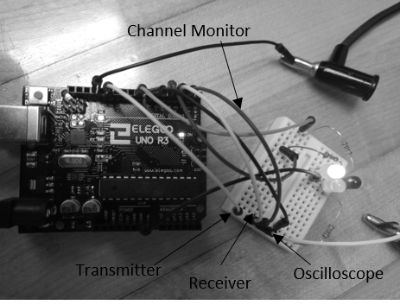

Figure - Test Setup with transmitter, receiver, channel monitor, and oscilloscope connected to the same node.

**BEGIN TEST:**

Some setup tests like powering on the system and checking the state of the channel monitor on startup.

**1.** Upon startup of the UUT, ensure that the line is IDLE. ***Indicate Pass or Fail here: ________***

**2.** Demonstrate that the receiver can receive 30 bytes (30 characters) without error by sending the following string, which is 30 characters long, “A cat found a hole with bunny.” Without the quotation marks. Observe the terminal for the received string, and indicate whether the received string is the same as the sent string. ***Indicate Pass or Fail here: ________***

**3.** If clock drift were to exist, then a 40-byte (40 character) or more transition would be received incorrectly because the sampling would shift to another half-bit period causing an incorrect read of data. Send the following string, which is 60 characters long, “Whenever the rain falls, I get umbrella to stay dry outside.” The varying selection of letters in this sentence can be used to verify that the receiver can receive any character with MSB = 0. If the receiver is designed correctly, is should be able to receive all of those characters. Verify that the string received by the receiver is the same string that was transmitted. ***Indicate Pass or Fail here: ________***

**RECEIVER FREQUENCY:**

Use an Analog Discovery device for the following steps, and remove the transmitter wire connection from the node. Setup a Patterns module on pin D0 of the Analog Discovery through the Waveforms program. The pattern will be 8 samples long as ‘10101010’ with 1 kHz frequency.

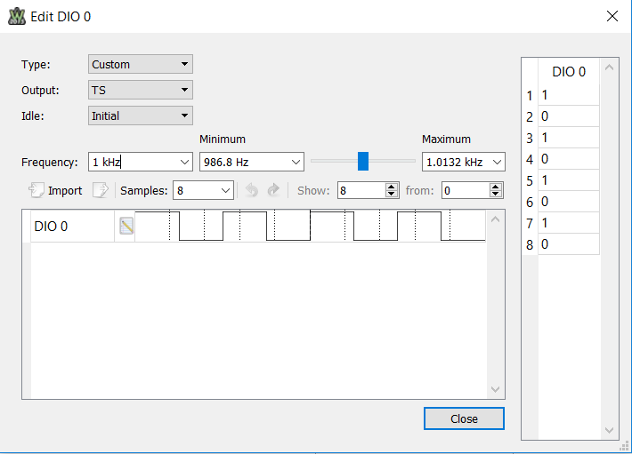

Figure 2 - Patterns module setup for D0

With the Analog Discovery Patterns module off, connect D0 to the input channel of an oscilloscope. Once connected, turn on the Patterns module. Verify that the pattern is 1 kHz with 1 ms high and low times using the oscilloscope.

**4.** Turn off the Patterns module and connect the D0 output to the input of the channel monitor and receiver through the same node. Open the PuTTy interface for viewing the received characters. Once it is ready, turn on the Patterns module for a second or two, and then stop it. The terminal should now display a string of U’s with its length proportional to the time the Patterns module was on. **Indicate Pass or Fail here: ________**

**5.** There is a 1.32% tolerance of the frequency of a transmitter in the network, so the frequency range is between 986.8 Hz and 1.0132 Hz. Change the frequency of the Patterns module to 986.8 Hz with the module off, and then repeat step 4. **Indicate Pass or Fail here: ________**

**6.** Change the frequency of the Patterns module to 1013.2 Hz with the module off, and then repeat step 4. **Indicate Pass or Fail here: ________**

**Witnesses**

Student Signature: ____________________ Student Name: ____________________ Date: ________

Student Signature: ____________________ Student Name: ____________________ Date: ________

Witness Signature: ____________________ Witness Name: ____________________ Date: ________

Professor Signature: ____________________ Professor Name: ____________________ Date: ________